What is SVG?

* SVG stands for Scalable Vector Graphics
* SVG is used to define graphics for the Web
* SVG is a W3C(world wide web consortium: संघ) recommendation
* The HTML <svg> Element
* The HTML <svg> element is a container for SVG graphics.
* SVG has several methods for drawing paths, boxes, circles,

<body>

    <svg width="500" height="500" style="border:2px solid black"  >

        <rect width='80' height="80" x="200" y="200 fill="skyblue" stroke="blue" stroke-width=10 rx="10"

       />

    </svg>

    <svg width="500" height="500" style="border:2px solid black"  >

        <circle cx="250" cy="250" r="100" fill="skyblue" stroke="blue" stroke-width=10

       />

    </svg>

    <svg width="500" height="500" style="border:2px solid black"  >

        <polygon points="242,33 298,172 477,197 333,264 388,411 240,326 96,408 148,263 5,176 187,172   "

        style=  "fill:rgb(7, 118, 7);

                stroke:rgb(1, 34, 17);

                stroke-width:5;

                " />

    </svg>

----------------------------------------------------------------------

<body>

    <canvas id="thecanvas" width="500" height="500" style="border:3px solid red">

    </canvas>

    <canvas id="thecanvas2" width="500" height="500" style="border:3px solid rgb(6, 2, 42)">

    </canvas>

    <canvas id="thecanvas3" width="500" height="500" style="border:3px solid rgb(6, 2, 42)">

    </canvas>

    <script>

        var canvas=document.getElementById('thecanvas');

        var cntext=canvas.getContext("2d");

        cntext.fillStyle='red'

        cntext.fillRect(150,200, 170,100)

        cntext.strokeStyle='blue'

        cntext.strokeRect(150,200, 170,100)

        var c = document.getElementById("thecanvas2");

        var ctx = c.getContext("2d");

            ctx.moveTo(0, 0);

            ctx.lineTo(200, 100);

            ctx.stroke();

       var a=document.getElementById("thecanvas3");

       var b=a.getContext("2d");

       b.strokeStyle="red"

            b.moveTo(150,250); //where from the line start

            b.strokeStyle="red"

            b.lineTo( 250,50); //ending point

            b.lineTo(350,250);

            b.lineTo(150,250);

            b.stroke();

        var circle = document.getElementById("thecanvas3");

        var cntx = circle.getContext("2d");

        cntx.strokeStyle="red"

        cntx.beginPath();

        cntx.arc( 250, 250,100,0,2*Math.PI  );

        cntx.stroke();

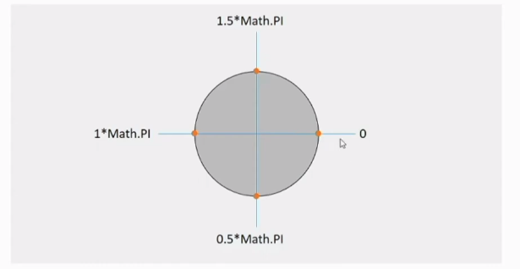

        var text = document.getElementById("thecanvas2");

        var cntx = text.getContext("2d");

        ctnx.font="20px arial";

        ctnx.fillStyle='red'

        ctnx.fillText("Aman",200,2000);

    </script>

</body>

# **HTML Image Maps**

## Image Maps

The HTML <map> tag defines an image map. An image map is an image with clickable areas. The areas are defined with one or more <area> tags.

## Create Image Map

Then, add a <map> element.

The <map> element is used to create an image map, and is linked to the image by using the required name attribute:

\**The name attribute must have the same value as the <img>'s usemap attribute* .

<img src="images/images.jfif" alt="" usemap="#aman">

    <map name="aman">

## The Areas

Then, add the clickable areas.

A clickable area is defined using an <area> element.

Ex.  <area shape="rect" coords="117,40,180,103" href="https://www.instagram.com/" alt=" insta logo">

### **Shape**

You must define the shape of the clickable area, and you can choose one of these values:

* rect - defines a rectangular region
* circle - defines a circular region
* poly - defines a polygonal region

### **Shape="rect"**

The coordinates for shape="rect" come in pairs, one for the x-axis and one for the y-axis.

* We should give two co-ordinates of rectangle
* Top-left and bottom-right

Ex. <area shape="rect" coords="34, 44, 270, 350" href="computer.htm">

### **Shape="circle"**

* To add a circle area, first locate the coordinates of the center of the circle.
* Then specify the radius of the circle:

Ex. <area shape="circle" coords="337, 300, 44" href="coffee.htm">

### **Shape="poly"**

The shape="poly" contains several coordinate points, which creates a shape formed with straight lines (a polygon).

This can be used to create any shape.

The coordinates come in pairs, one for the x-axis and one for the y-axis:s

Ex. <area shape="poly" coords="140,121,181,116,204,160,204,222,191,270,140,329,85,355,58,352,37,322,40,259,103,161,128,147" href="croissant.htm">s

 <img src="images/images.jfif" alt="" usemap="#aman">

    <map name="aman">

        <area shape="" coords="" href="https://en.wikipedia.org/wiki/HTML5#:~:text=HTML5%20is%20a%20markup%20language,as%20the%20HTML%20Living%20Standard." alt="">

        <area shape="rect" coords="117,40,180,103" href="https://www.instagram.com/" alt=" insta logo">

        <area shape="circle" coords="58,49,28" href="https://www.facebook.com/" alt="">

        <area shape="poly" coords="101,31,52,62,69,117,132,117,149,64" href="" alt="">

    </map>